**BUG TEMPLATE: SPICY**

**BUG ID**: 01

**BUG NAME**: Search bar is not working on admin page.

**ASSIGNEE**: New assigned

**STATE**: New

**DESCRIPTION**: 1. Open spicy application.

2. In admin page.

3.Please refer the screenshot

**OBSERVATION**: Here search bar is not working.

**EXPECTED**: Search bar should work.

**PRIORITY**: High

**SEVERITY**: Low

**ATTACHMENT**:

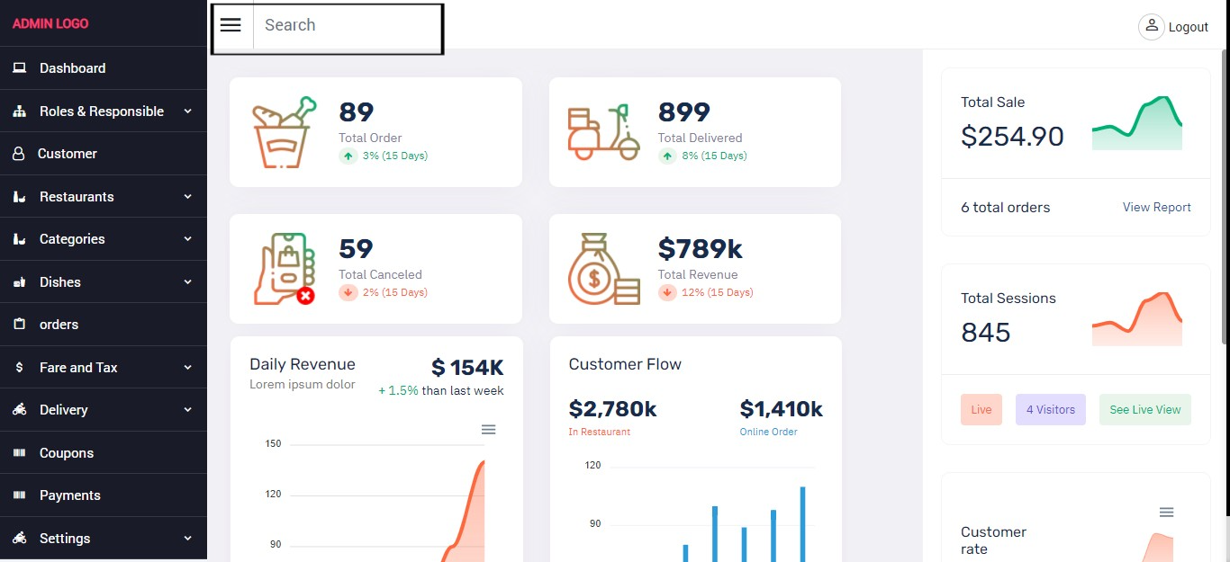

**BUG ID**: 02

**BUG NAME**: Delivery dashboard is not working on admin page.

**ASSIGNEE**: New assigned

**STATE**: New

**DESCRIPTION**: 1. Open spicy application.

2. In admin page.

3. Go to Delivery list.

3.Please refer the screenshot

**OBSERVATION**: Here Delivery dashboard is not working.

**EXPECTED**: Delivery dashboard should work.

**PRIORITY**: High

**SEVERITY**: Low

**ATTACHMENT**:

